**Bi-National Call on Method Validation 2024**

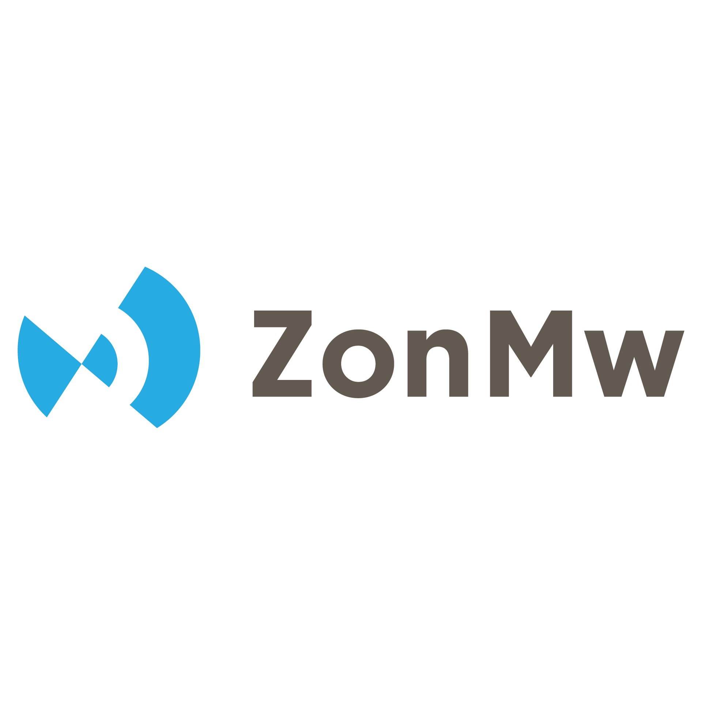

**“Closing the gap –**

**validating and implementing new approach methodologies in a regulatory context”**

**Guidelines for applicants - Project description**

**Checklist for coordinators**

You must be able to tick all the boxes in order to be eligible to apply to the call.

**General conditions:**

The project proposal aims to validate a new approach method (NAM).

The project proposal targets one of the two modules described in the call text.

The current TRL of the project corresponds to the eligible TRLs as specified in the call text.

The method described is human relevant.

**The composition of the consortium and eligibility of the consortium partners:**

The project proposal involves at least one eligible research partner from each country participating in the call.

Project partners should contain at least one partner from a research institute and at least one partner from a commercial organization.

The consortium coordinator and each of the additional consortium partners asking to be financed are eligible to receive funding from the two funding organizations’ participating in the call (please refer to the national annexes).

By submitting the proposal, all consortium partners agree with and confirm their participation in the project.

**Further instructions**

Please follow the suggested outline stated below, when preparing your project proposal for the indicated funding call. The maximum funding duration will be 3 years, please plan accordingly.

Please refer to the call text (valNAM.eu) and the specific national annexes, for all required information that shall be included in the proposal. Please pay specific attention to section 2 of the call text and the indicated considerations.

Project proposals need to be submitted electronically only; a signed hard copy of the proposal is not required at this stage!

**Please submit the project proposal as a single pdf file via the submission portal.** You may upload additional files as outlined in the call text.

**Please use the following link to submit your proposal:**

<https://ssl.vdivde-it.de/positrons-en/calls/2407>

Deadline for submission is friday **28/04/2025, 23:59pm.**

Please note that the provided pdf file must be encryption-free and may not exceed a maximum of 20 pages (excluding cover page and annexes, minimum font size 11 pt, Arial font). The regular character spacing and a line spacing of at least 1.15 have to be used. The page format is A4, and all margins (top, bottom, left, right) should be at least 20 mm (excluding footers and headers).

Project proposals not complying with the aforementioned guidelines may be excluded from the evaluation process and will be rejected without additional explanatory statement. Given the bi-national character of the call, a submission in English is mandatory.

Please note:

* Proposals that do not meet the national eligibility criteria and requirements may be rejected without further review.
* Only one proposal per bi-national consortium shall be submitted.
* Individual project partners may apply as a coordinator for only one project, may however choose to participate as a partner in other consortia.

Please do not hesitate to contact the acting joint call secretariat (JCS) for any further questions regarding preparation, submission, and evaluation of proposals. Questions concerning specific national regulations may also be addressed to the JCS and will be redirected to respective funding parties on a case by case basis.

The JCS is hosted by the german project management agency VDI/VDE Innovation + Technik GmbH:

Ms. Dr. Sandra Paschkowsky, Mrs. Dr. Anke Teichmann and Mrs. Dr. Sophia Bauch

Telefon: 030 310078-5585

Email: valnam@vdivde-it.de

General information (cover sheet)

|  |  |
| --- | --- |
| **Project title** | *maximum of 200 characters (excluding spaces)* |
| **Acronym** | *maximum of 15 characters, may contain numbers, letters or hyphens* |
| **Project duration** | *in months (max. 36 months)* |
| **Total costs of the project** | including in kind contributions and industry-matching |
| **Requested funding** | total sum to be awarded by funding parties |
| **Keywords** | please identify between three and seven keywords that represent the scientific content (organ-on-chip, organoids, class of substances, methods, tools, regulatory context, etc.) |
| **Short description**  *maximum of 2000 characters (excluding spaces), non-confidential* | |

***List of research partners (in here defined as individual researchers)***

|  |  |  |  |
| --- | --- | --- | --- |
| **No.** | **Research Partner** | **Institution, department, full affiliation**  **(address, zip code, city, country)** | **E-mail address** |
| ***1*** |  |  |  |
| ***2*** |  |  |  |
| ***…*** |  |  |  |

**I. Module:**Please indicate and explain if your project addresses module I or II and why. Please note that proposals shall provide sufficient evidence to justify their module selection.

**II. Objectives**

**2.1 Main objectives of the project**

Briefly describe the main objectives of the project including potential exploitation strategies. Thus, you shall ensure that the objectives are stated clearly and are realistic, measurable and achievable within the anticipated project timeframe. Objectives should be consistent with the aims of the funding call and contribute to the implementation of new approach methodologies.

**2.2 Project congruence with the fundings’ objectives of the call**

Please provide relevant information regarding the congruence of your project proposal with the main aims of the funding program. This shall include but may not be limited to providing evidence for the human relevance of the proposed method(s). Please also provide evidence for the benefit of the proposed bilateral collaboration. You shall also include a justification for the need for validation of the proposed method (e.g. beneficiary, end-user, purpose, etc.); highlighting a specific regulatory need.

**2.3 Scientific and/or technical objectives of the project**

Please state your specific objectives regarding, e.g. validation, regulation, quality, and data management.

**III. Current state of science and technology, project development state**

**3.1 State of science and technology (including alternative solutions, freedom to operate, literature research, corresponding regulatory framework)**

State-of-the-art sciences and technologies that are relevant for the success of the proposed project need to be inquired and outlined (e.g. including strength and weaknesses of alternative approaches, legal aspects opposing the utilization of project results, literature research).

Please provide details on the current regulatory framework relevant to the method proposed. If you have already been in contact with authorities regarding the acceptance of your method please provide details on the feedback received (if applicable), you may also provide specific documentation as an annex. If you have not been in contact with authorities please provide details on relevant authorities in question.

Please make a statement on intellectual property rights, which are or may be affected by the implementation of the project.

* Text example if the applicant holds all property rights: *We have established the state of the art in the fields of activity affected by this project by means of current information research. To the best of our knowledge, the project is not already the subject of other research, developments, investigations, or patents and there are no industrial property rights or applications for industrial property rights that would prevent the project from being carried out and the results from being exploited at a later date.*

If third-party property rights are affected by the project, please list them separately (in table form, if applicable) and confirm that the rights owners have given their consent to the implementation of the project (freedom-to-operate).

**3.2. Method/project readiness: relevant previous work of the applicants**

Describe your previous research activities and experience with regard to validation and or method development. Particularly, preliminary results that provide evidence for the technology readiness of the proposed method are expected. State the reasons justifying the readiness for a validation study and the indicated module selection. You will also have to provide detailed SOPs for the method in question as an annex. If there are any confidentiality concerns, please contact the JCS.

**3.3 Project management: expertise of the applicants with regard to method validation**

Describe the structure of the consortium and the contribution of each individual regarding the project objectives.

If feasible, describe briefly the preliminary work of each partner that contributed to achieving the above-mentioned level of development. Justify, in general terms, which previous work as well as structural and financial prerequisites qualify the partner(s) to carry out the project.

**IV. Detailed description of the working plan**

Please provide a brief overview of the overall structure of the working plan and a timing of the work packages (Gantt chart including all work packages and sub work packages, their duration in project months, milestones, etc.) using the table below.

**4.1 Project-related resource management**

Please provide a detailed working plan including proposed work packages, timing, resources, and anticipated results using the following table. Please consider specific module dependent requirements such as consulting regulatory authorities before or during the project duration.

|  |  |  |  |
| --- | --- | --- | --- |
| [Work package no.] | [Work package title] | [Total personnel months (PM)] | [Start month Mx – end month My] |
| **Mainly responsible:** [partner] | | | |
| **Involved parties:** [partner, subcontractors, etc.] | | | |
| **Objectives:** | | | |
| ***Work description:*** *Please provide a detailed description for each work package including the distribution of tasks between the partners/subcontractors.*  *You should give enough detail for each work package to justify the proposed personnel months and other allocated resources.* | | | |
| ***Expected results / deliverables:***  *What is the output of the work package?* | | | |

**4.2 Work and milestone schedule**

Please define milestones, e.g. important interim goals representing project progress or critical decision points. Note that achievements of milestones must be measurable. For this purpose, list the indicators of success for each milestone to show how you will confirm that the milestone has been achieved. The due date is measured in months beginning at the start of the project. You may provide a GANTT chart for this purpose.

**4.3 Risk assessment and contingency**

Please describe any critical risks that could impair the objectives or milestones of the project. Detail the risk avoidance or mitigation strategies and any contingency plans (see table below).

|  |  |  |  |
| --- | --- | --- | --- |
| Description of risk | Level of likelihood (low, medium, high) | Related work package | Proposed risk mitigation measures/contingency plans |
|  |  |  |  |

**V. Exploitation and implementation strategy**

5.1 Economic (regulatory), scientific, and technical exploitation of results

In the case of positive results, please outline how you aim to achieve regulatory acceptance within 2-5 years after project completion. Please provide details on necessary steps to take on the road to regulatory acceptance, please also indicate who will take charge of said tasks upon project realisation. You may also outline how individual partners may use projects results independent of regulatory acceptance.

If applicable, please comment on potential plans for commercialising the method developed. Hence, describe a potential economic exploitation of the results and possible next steps after successful completion of the project.

Describe the scientific/technical exploitation including possible timescales. The planned objectives are useful, e.g. for public tasks, databases, networks, transfer. Outline the strategy for knowledge management and protection. Include measures to provide open access to peer-reviewed scientific publications, which might result from the project. For each partner, describe the scientific and technical exploitation of results, i.e. gain in knowledge, publications, sharing of data, use of results for other projects, etc.

Please outline your data management plan (knowledge management strategy). What types of data will the project generate/collect? How will this data be exploited and/or shared/made accessible for verification and re-use? How will this data be curated and preserved?

5.2. Impact

In case of successful completion of the project and further development steps, describe the impact this method may have in relation to the regulatory need addressed. You may also comment on topics such as green chemistry, EU sustainability goals, one health, patient care, reduction in animal experiments, etc.

**VI. Collaboration with third parties**

In case of projects with wide-ranging application potential (e.g. joint research projects), the division of work/collaborations (academia, major enterprises/small and medium-sized enterprises) has to be outlined.

**VII. Necessity for funding**

Please outline why the requested funding is required to achieve the project goals and execute the project (economic and scientific-technical risks for the applicant).Thus highlight, why the realisation of the project is not feasible without the requested funding (Internal funds are not available. Sponsorship by third-party funding provided by government, EU, or other sources was considered and is not applicable. Other modes of sponsorship are not available.).

**Annex 1: Project budget** (ca. 1 page)

*Please provide sufficient information to assess the overall budget. For each partner (in here defined as research institution not individual researchers), please break down the total costs of the project, their own contribution, and the requested BMBF funding related to the working plan. Please specify the nature of the costs for each partner. Provide a tabular overview of the funding for the project (table 1). Take into account contributions from other funders or in kind contributions, if applicable. Please briefly explain per line and item what the requested funding is needed for (Table 2)*

*Table 1: Budget*

|  |  |  |  |
| --- | --- | --- | --- |
|  | Partner 1  (Coordinator) | Partner 2 | Partner 3 |
| Personnel |  |  |  |
| Consumables |  |  |  |
| Equipment |  |  |  |
| Subcontracts[1] |  |  |  |
| Travel expenses |  |  |  |
| Miscellanous (please specify) |  |  |  |
| **Total cost** |  |  |  |
| Funding rate (%) |  |  |  |
| Overhead (please note, that dutch partners are not eligible for an overhead)[2] |  |  |  |
| **Requested funding** (including overhead) |  |  |  |

*Table 2: Budget Justification*

|  |  |  |  |
| --- | --- | --- | --- |
|  | Partner 1  (Coordinator) | Partner 2 | Partner 3 |
| Personnel |  |  |  |
| Consumables |  |  |  |
| Equipment |  |  |  |
| Subcontracts |  |  |  |
| Travel expenses |  |  |  |
| Miscellanous (please specify) |  |  |  |
| **Total cost** |  |  |  |
| Funding rate (%) |  |  |  |
| Overhead |  |  |  |
| **Requested funding** (incl. overhead) |  |  |  |

1. Please refer to the National Annexes for further information or contact the JCS.
2. Please refer to the National Annexes for further information.